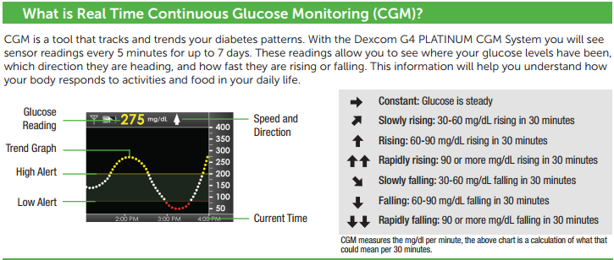
Daily use
Please, keep your receiver within 15 feet of you at all times.
Please, connect your CGM receiver to charger every night (like your cellphone). Charge the receiver battery using only the battery charger provided (Dexcom) in AC power outlet. Do not use any other battery chargers. Fully charging an empty battery takes about 3 hours. You may use the CGM receiver while it is charging.
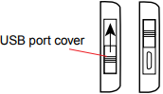
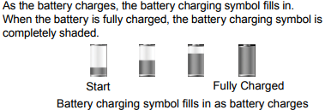
Return appointment ______________________________
Please, bring your receiver, charger and transmitter (it will be taken off during your return appointment). On your return appointment we will download the receiver, review CGM data for patterns and trends, and adjust medication/nutrition as needed.

Technologist _______________________________

Physician _________________________________ Phone ___________________________
Technical support: (888) 738-3646

Calibrating
Please use your blood glucose meter to calibrate the Dexcom G4 Platinum Professional System. At the end of the 2-hour startup period, please enter two calibrations before any sensor glucose readings will show. Calibration blood glucose values must be entered into the receiver within 5 minutes of testing with your blood glucose meter.
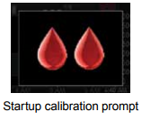
Startup calibration
- At the end of the 2-hour startup period, the startup calibration double blood drop prompt will appear on the receiver screen. Press the SELECT button to clear this alert.
- Wash and dry your hands.
- Take finger-stick blood glucose measurement using your blood glucose meter.
- From any trend graph, press the SELECT button to get to the Main Menu.
- Press the DOWN button to highlight “Enter BG”. Press the SELECT button.
- For the startup calibration, the default blood glucose value on the receiver is 120 mg/dL. Press the UP and DOWN button to enter the exact blood glucose value from your glucose meter. Press the SELECT button.
- Press the SELECT button again to accept the calibration.
- Repeat steps c to g to enter a second blood glucose value.

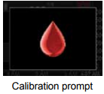
Calibration update:
The calibration single blood drop prompt will appear on the receiver screen to let you know a calibration update is needed. To confirm this prompt, press the SELECT button.
After the startup calibration, calibration updates must be entered once every 12 hours at a minimum.
NOTE: Calibrating less than the recommended amount may result in inaccurate sensor glucose readings. You can enter more calibrations each day if you want.

Safety notes
This Continuous Glucose Monitoring system (CGM) is a glucose-monitoring device for detecting trends and tracking patterns in adults with diabetes. The CGM is for multiple patient use. Contraindications: remove the CGM prior to MRI, CT scan or diathermy treatment (not safe for magnetic resonance). Taking acetaminophen while wearing sensor may falsely raise your sensor glucose readings. The transmitter is cleaned and disinfected after use in each patient. The receiver is used with a receiver shield replaced for each patient. If sensor breaks and no portion is visible above the skin, do not attempt to remove it. Contact the doctor if any signs of infection or inflammation. Sensor placement is not approved for sites other than under the skin of the belly (abdomen). Contact your medical team or Dexcom (877)-339-2662 or www.dexcom.com for detailed safety information and other details on use of this Dexcom G4 Platinum Professional System.

